Subtitle: Net ODA in 2014, x largest multilateral

Title: Name of multilateral organisation

PAGE1: MULTILATERAL PROFILES TEMPLATE 2016

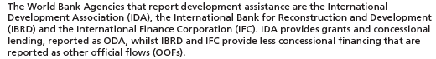

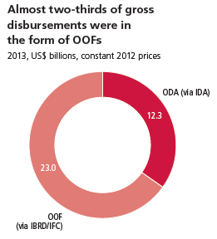

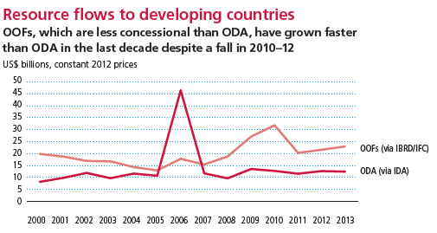

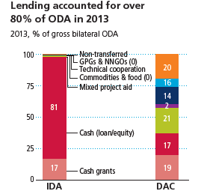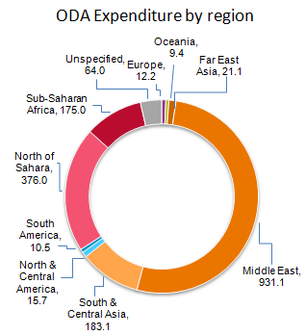

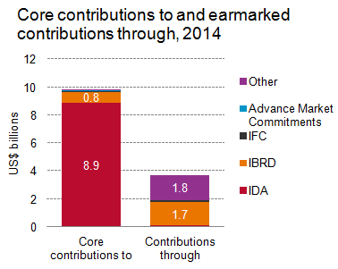

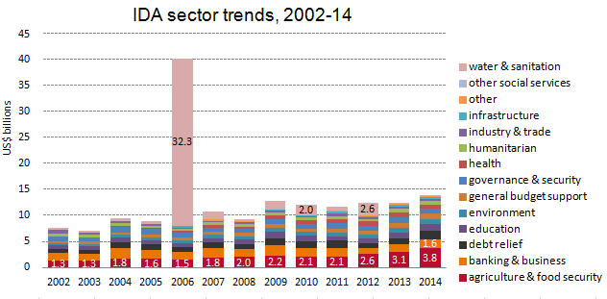

PAGE2: MULTILATERAL PROFILES TEMPLATE 2016

FOR MULTILATERALS IN GROUP A

IDA, Top five sectors by top five purpose codes, 2014

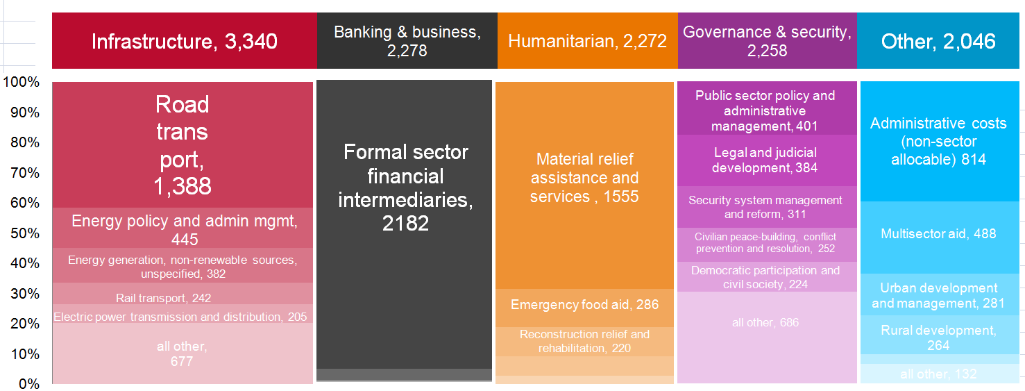

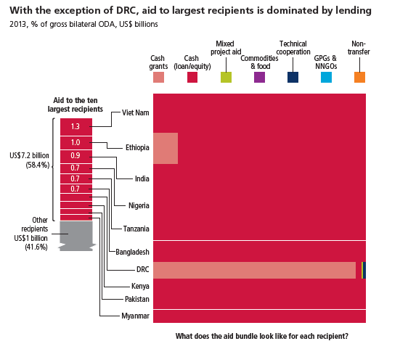

PAGE2: MULTILATERAL PROFILES TEMPLATE 2016

FOR MULTILATERALS IN GROUP B

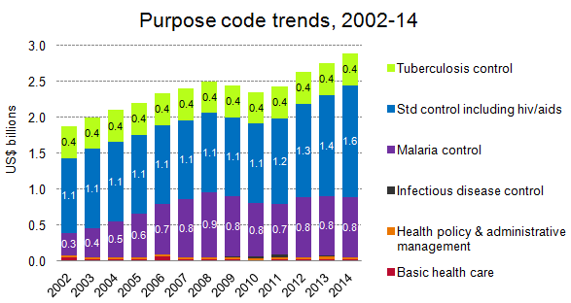

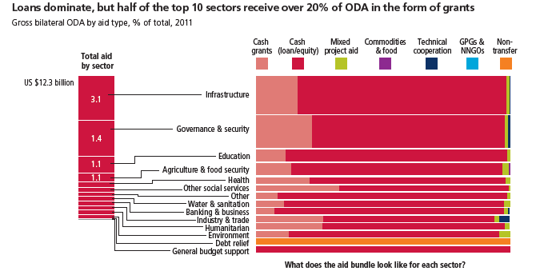



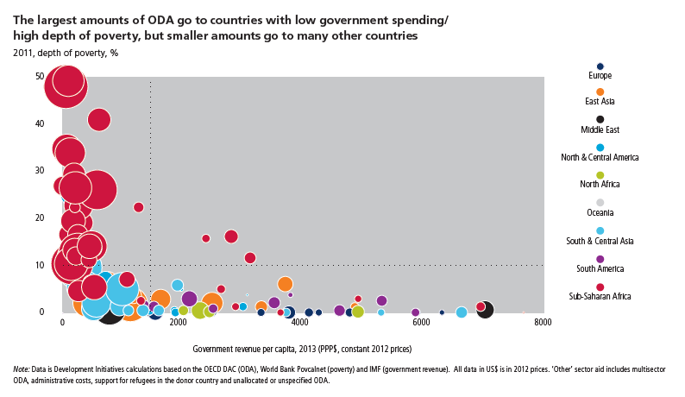

PAGE3: MULTILATERAL PROFILES TEMPLATE 2016

Space for:

Source and notes on the profiles.

